MINNESOTA SESQUICENTENNIAL FARM

RECOGNITION PROGRAM

Thank you for your interest in the 2026 Minnesota Sesquicentennial Farm recognition program, sponsored by the Minnesota Farm Bureau Federation.

Please fill out the application completely; incomplete applications will not be considered. All qualifications must be met at the time the application is submitted.

The annual application deadline is the second of March (March 2, 2026) and must be received by the Minnesota Farm Bureau Federation by that date. Qualified applications received after March 2 will be considered for the following year (2027). This is not a postmark date.

Qualifications for inclusion are as follows:
- The farm must be at least 150 years old by the end of 2026 according to abstract of title, land patent, original deed, county land records, court file in registration proceedings or other authentic land records.
  - The applicant should verify that the farm qualifies as a Sesquicentennial Farm, but we do not require direct proof.
  - Please do not send supporting documentation, only the completed application. Any supporting documents will not be considered part of the application.
- Farm is family-owned for 150 years or more.
  - “Family” is defined as
    - Parents, grandparents, aunts, uncles, brothers, sisters, sons, daughters, first cousins and direct in-laws (spouse, father, mother, brother, sister, daughter, son-in-law)
- Family ownership must be continuous.
- Continuous residence on the farm is not required.
- The farm should consist of 50 or more acres (interstate Minnesota).
- Farm must be currently involved in agricultural production.
- A farm may only be recognized once.

Please return the completed applications to:
Minnesota Farm Bureau Federation
Sesquicentennial Farms
PO Box 64370
St. Paul, MN 55164
info@fbmn.org

Qualifying farms will receive:
- One personalized certificate of recognition, signed by the Governor of Minnesota, the Commissioner of Agriculture or Minnesota, and the President of the Minnesota Farm Bureau Federation.
- One metal sign, measuring 6 inches by 17.5 inches, proclaiming the farm is a “Sesquicentennial Farm.”



MINNESOTA SESQUICENTENNIAL FARM

RECOGNITION PROGRAM

Recognition ceremonies are handled by your local county Farm Bureau where this milestone may be celebrated with friends, family, and neighbors.

Your certificate and sign will be sent directly to you in June. Only one sign and certificate will be awarded per farm. Your county Farm Bureau president will contact you if any additional local recognition will take place.

While the Minnesota State Fair does not conduct a recognition ceremony during the Minnesota State Fair, we encourage those who have been awarded a Sesquicentennial Farm this year to visit the Minnesota Farm Bureau booth where your application may be viewed, and you may request a special commemorative Sesquicentennial Farm rosette.

The Sesquicentennial Farm status is only conferred on a farm one time. New owners from the same “family” after a farm has already been designated a Sesquicentennial Farm may not reapply or request a new certificate.

The Minnesota Farm Bureau thanks you for your interest in the Sesquicentennial Farm Program.

Century Farm Program

In addition to sponsoring the Sesquicentennial Farm Program, the Minnesota Farm Bureau co-sponsors with the Minnesota State Fair to honor Minnesota families who have owned their farms for at least 100 years, are at least 50 acres in size and are currently involved in agriculture.

For more information on the Century Farms Program or for the application form, contact the Minnesota State Fair Recognition Programs at centuryfarms@mnstatefair.org or call 651-288-4417.

DEADLINE: MARCH 2, 2026
MINNESOTA FARM BUREAU

SESQUICENTENNIAL FARM APPLICATION – 2026
PLEASE TYPE OR PRINT CLEARLY

Main Contact Name(s): ____________________________________________________________________

Main Contact Information: __________________________________________________________________
(area code) (phone number) (email address)
Main Contact Mailing Address: ______________________________________________________________
(street) (city) (state) (zip)
Present Owner of the Farm: ________________________________________________________________

Name(s), or Family Name, or Farm Name to Appear on Certificate:

_______________________________________________________________________________________

Farm Address: __________________________________________________________________________
(street) (city) (state) (zip)
Section: ___________________ Township: _____________________ County: _______________________

Number of acres in the farm at the present time: __________

Year of original purchase by a member of your family: __________

Has farm been previously registered as a Century Farm? __________ If so, when? ______

Legal Description of Land (from deed, abstract, tax statement, etc): __________________________________

________________________________________________________________________________________

PROOF OF 150 YEARS OWNERSHIP

NAME | YEARS OF OWNERSHIP  FROM - TO | RELATIONSHIP TO PREVIOUS OWNER
First owner

Next owner

Next owner

Next owner

Next owner

The above evidence of continuous family ownership is taken from one or more of the following records.
Check those that apply: Please do not send originals or copies of records.
( ) Abstract of Title ( ) Land Patent ( ) Court File in Registration Proceedings
( ) Original Deed ( ) County Land Record ( ) Other_____________________

I hereby certify that the information listed above is correct to the best of my knowledge and belief.

_______________________________________ _________________________________
(signature of present owner) (date)

ADDITIONAL INFORMATION

Any information you can add to this form will be most valuable to future historians. The questions below are only a guide. Feel free to add other data, especially family or pioneer stories concerning the farm and the area around it. This is not a requirement for Sesquicentennial Farm certification.

From whom was the farm purchased? _________________________________________________________

How many acres were in the original parcel? ____________________________________________________

What was the cost of the land per acre?________________________________________________________

Where was the first family owner born? ________________________________________________________

Did he/she engage in any trades or occupations other than farming? _________________________________

If so, please list: __________________________________________________________________________

Was this a homestead? ____________________________________________________________________

Is the original home, any portion of it, or any other original buildings still standing? ______________________

When was the present home built?____________________________________________________________

What were the farm’s major crops or products? __________________________________________________

Additional comments: ______________________________________________________________________

________________________________________________________________________________________

________________________________________________________________________________________

________________________________________________________________________________________

________________________________________________________________________________________

________________________________________________________________________________________

________________________________________________________________________________________
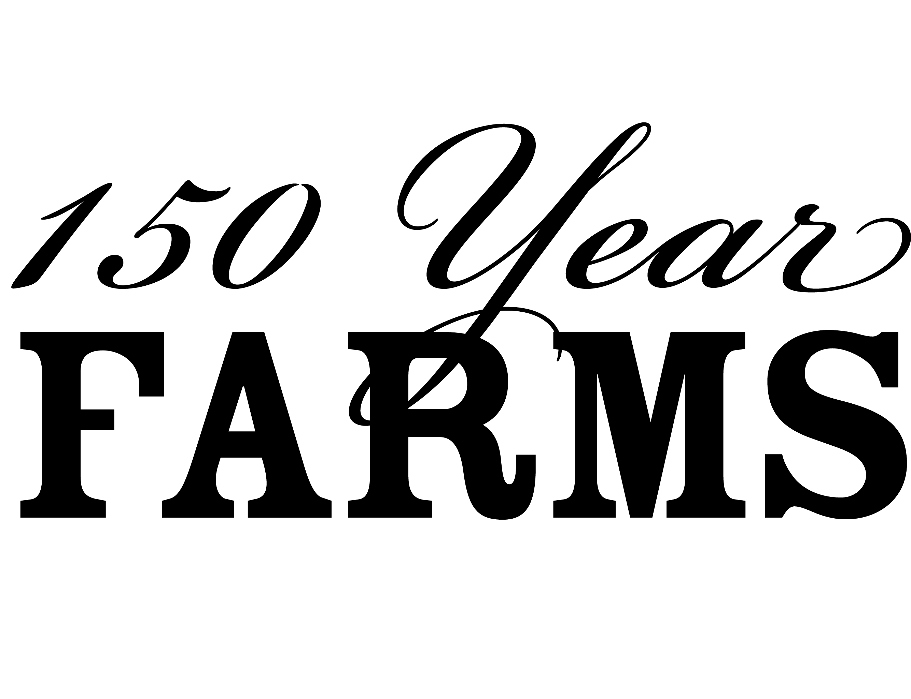

Return application to:
Minnesota Farm Bureau Federation
Sesquicentennial Farms
PO Box 64370
St Paul, MN 55164
info@fbmn.org

Questions? Email: info@fbmn.org
or call: 651-768-2111

